Rare Hero Cards:

Unit Cards: (Race, Class, Strength, Level, Ability (if any))

1) Dovakhiin: Will not ally with Dragons

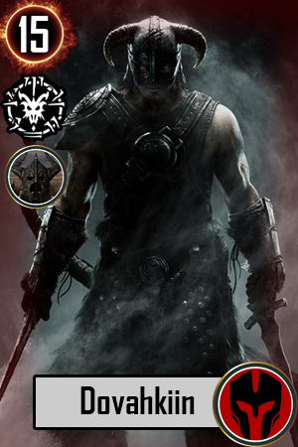

The Dragonborn, the permanent Dragon Slayer

Class: Can be placed on any zone. [The only card with this ability]

Special: Ability to use one Dragon shout in a battle.

Strength: 15

Cannot be buffed or weakened with external cards

2) Miraak:

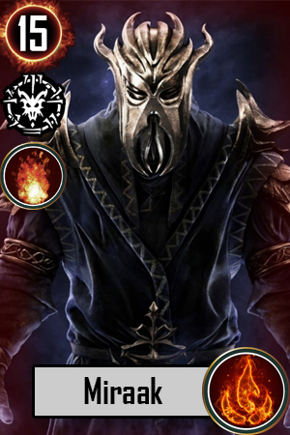

The Last Dragonborn, the permanent Dragon Slayer

Class: Mage

Strength: 15

Special: Ability to use one Dragon shout in a battle.

Can bend will of one dragon card on the opposing sides if they have any dragon and use it on Miraak's side.

Cannot be buffed or weakened with external cards

3) Alduin: Will not ally with Blades

First Born of Akatosh. The world eater.

Class: Can be placed on frontlines or mage

Strength : 15

Special: Ability to use one Dragon shout in a battle.

Cannot be buffed but can be weakened with Dragonrend

4) Serana

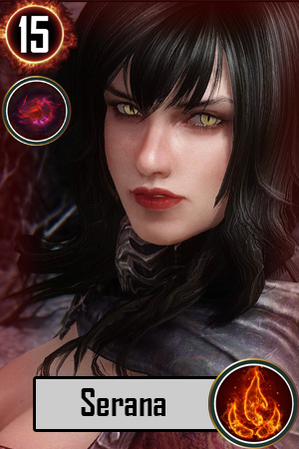

Daughter of the Coldharbour. Pure Blooded Vampire.

Class: Mage

Strength: 15

Special: Life Drain. Completely drain a card's life force and eliminate it, unless they are buffed with Dawnguard's sunlight.

Cannot be buffed but can be weakened with Sunhallowed Auriel's Bow (Dawnguard)